**Project Design Phase - II Data Flow Diagram & User Stories**

|  |  |
| --- | --- |
| Date | 14 October 2022 |
| Team ID | PNT2022TMID04463 |
| Project Name | SMARTFARMER – IOT ENABLED SMART FARMING  APPLICATION |
| Maximum Marks | 4 Marks |

**Data Flow Diagrams:**

A Data Flow Diagram (DFD) is a traditional visual representation of the information flows within a system. A neat and clear DFD can depict the right amount of the system requirement graphically. It shows how data enters and leaves the system, what changes the information, and where data is stored.

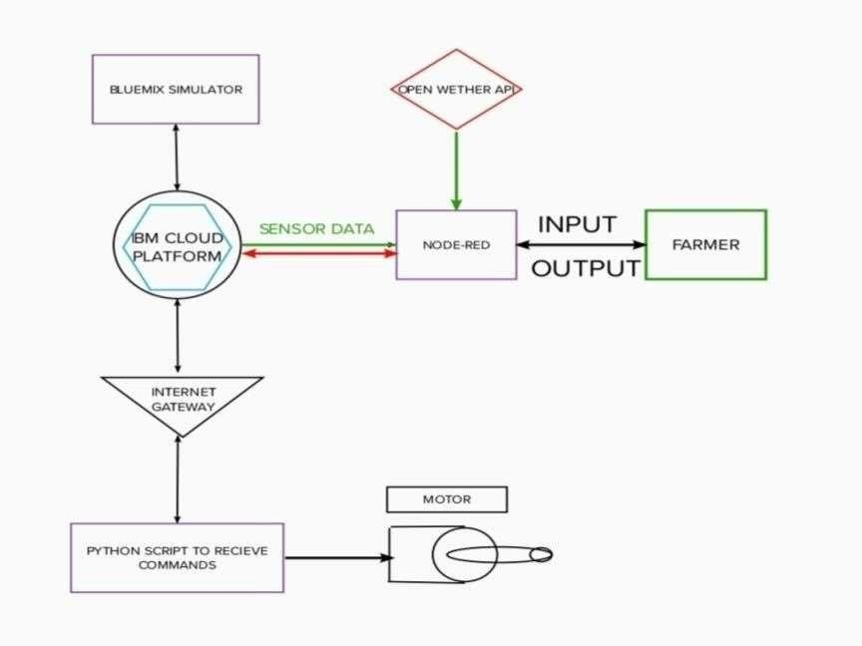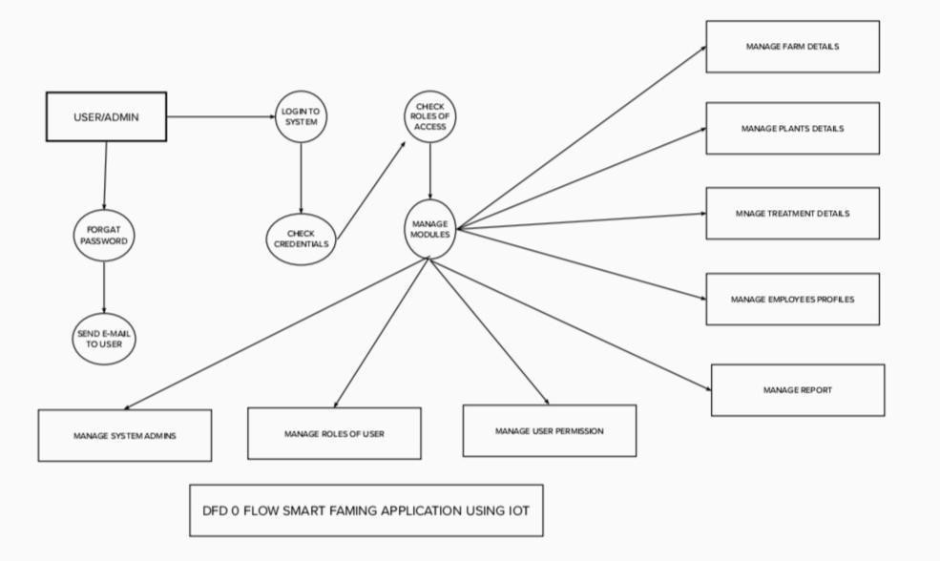

* The different sensors used to measure soil moisture , temperature ,humidity , weather and stored the data in IBM CLOUD
* Arduino UNO is used as a processing Unit that process the data obtained from the sensors and whether data from the weather API.
* NODE-RED is used as a programming tool to write the hardware, software, and APIs. The MQTTprotocol is followed for the communication.
* All the collected data are provided to the user through a mobile application that was developed using the MIT app inventor. The user could plan through an app, weather to water the crop or not depending upon the sensor values. By using the app they can remotely operate to the motor switch which is watering the plant .

**User Stories**

Use the below template to list all the user stories for the product.

|  |  |  |  |  |  |  |
| --- | --- | --- | --- | --- | --- | --- |
| **User Type** | **Functional Requirement (Epic)** | **User Story Number** | **User Story / Task** | **Acceptance criteria** | **Priority** | **Release** |
| Customer (Mobile user) | Registration | USN-1 | As a user, I can register for the application by entering my email, password, and confirming my password. | I can access my account / dashboard | High | Sprint-1 |
|  |  | USN-2 | As a user, I will receive confirmation emailonce I have registered for the application | I can receive confirmation email & click confirm | High | Sprint-1 |
|  |  | USN-3 | As a user, I can register for the applicationthrough Facebook | I can register & access the dashboard with Facebook Login | Low | Sprint-2 |
|  |  | USN-4 | As a user, I can register for the applicationthrough Gmail |  | Medium | Sprint-1 |
|  | Login | USN-5 | As a user, I can log into the application byentering email & password |  | High | Sprint-1 |
|  | Dashboard |  |  |  |  |  |
| Customer (Web user) |  |  |  |  |  |  |
| Customer Care Executive |  |  |  |  |  |  |
| Administrator |  |  |  |  |  |  |
|  |  |  |  |  |  |  |
|  |  |  |  |  |  |  |
|  |  |  |  |  |  |  |